**DEPLOYING A WEBSITE USING MULTILPE AWS SERVICES**

***A Summer Internship Report submitted in partial fulfillment of the***

***requirements for the award of degree of***

**BACHELOR OF TECHNOLOGY**

**In**

**Computer Science and Engineering Artificial Intelligence & Machine Learning**

## Submitted by:

## BATTULA KOTESWRARAO

## 22P31A1221



**Computer Science and Engineering Artificial Intelligence & Machine Learning**

**ADITYA ENGINEERING COLLEGE & TECHNOLOGY (A)**

**Approved by AICTE, Permanently affiliated to JNTUK & Accredited by NAAC with ‘A+’ Grade**

**Recognized by UGC under the sections 2(f) and 12(B)of the UGC act 1956**

**Aditya Nagar, ADB Road –Surampalem 533437, E.G. Dist., A.P.,**

**2024-2025.**

**ADITYA ENGINEERING COLLEGE & TECHNOLOGY (A)**

**Approved by AICTE, Permanently Affiliated to JNTUK & Accredited by NAAC with ‘A+’ Grade**

**Recognized by UGC under the sections 2(f) and 12(B) of the UGC act 1956**

**Aditya Nagar, ADB Road - Surampalem – 533437, E.G.Dist., A.P.,**

**Department of Computer Science and Engineering Artificial Intelligence & Machine Learning**



**CERTIFICATE**

This is to certify that the Internship report entitled *“***Deploying a Website Using Multiple AWS Services***”* is being submitted by

**BATTULA KOTESWRARAO 22P31A1221**

In partial fulfillment of the requirements for award of the B.Tech degree in Computer Science and Engineering Artificial Intelligence & Machine Learning for the academic year 2024-2025.

**Internship Coordinator Head of the Department**

**Mrs. J. Sailaja M.Tech Mr. R V V N Bheema Rao M.Tech, (Ph. D)**

**Assistant Professor Associate Professor Department of IT Department of IT**

**DECLARATION**

I hereby declare that the Internship entitled **“Deploying a Website Using Multiple AWS Services” i**s a genuine report. This work has been submitted to the **ADITYA COLLEGE OF ENGINEERING & TECHNOLOGY (A),** Surampalem, permanently affiliated to **JNTUK, KAKINADA** in partial fulfillment of the **B.Tech** degree**.**

I also hereby declare that this internship report not submitted in full or partial any other university for any degree.

**NAME OF THE STUDENT**

**BATTULA KOTESWRARAO**

**(22P31A1221)**

**Institute Vision & Mission**

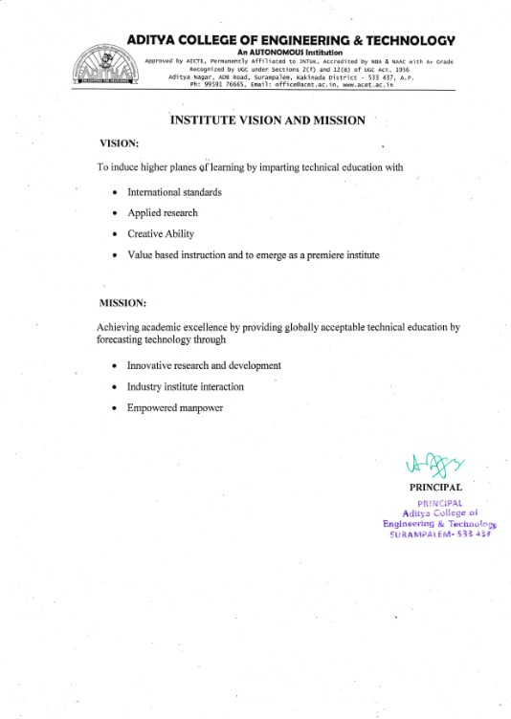

**INTERNSHIP COMPLETION CERTIFICATE**

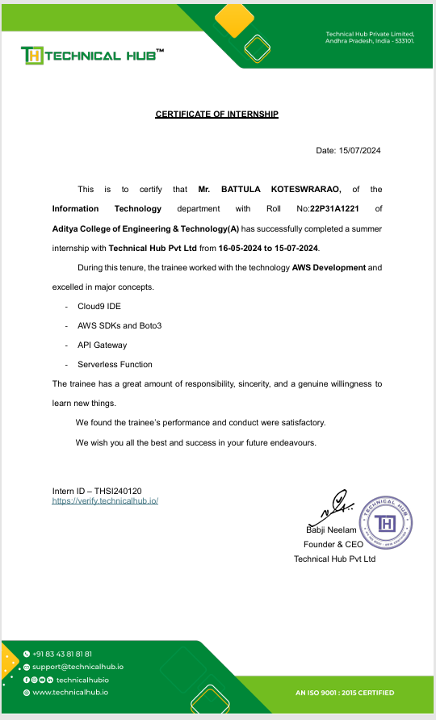

**ACKNOWLEDGEMENT**

I offer my sincere thanks to precious and dynamic Principal, **Dr. A. Ramesh**, **Aditya College of Engineering & Technology** **(A)** for his co-operation.

My sincere thanks to **Mr. R V V N Bheema Rao M Tech, (Ph. D)** Head of the department of Information Technology for his valuable support.

I express my sincere gratitude to my internship guide **Mrs. J. Sailaja M.Tech** Department of Information Technology , for his valuable guidance and encouragement which has been helpful in successful completion of this internship.

With immense pleasure I would like to express my deep sense and heart full thanks to the management of Aditya College of Engineering & Technology (A).

**Learning Objectives / Internship Objectives**

1. Internships are generally thought of to be reserved for college students looking to gain experience in a particular field. However, a wide array of people can benefit from Training Internships in order to receive real world experience and develop their skills.
2. An objective for this position should emphasize the skills you already possess in the area and your interest in learning more
3. Internships are utilized in a number of different career fields, including architecture, engineering, healthcare, economics, advertising and many more.
4. Some internships are used to allow individuals to perform scientific research while others are specifically designed to allow people to gain first-hand experience working.
5. Utilizing internships is a great way to build your resume and develop skills that can be emphasized in your resume for future jobs. When you are applying for a Training Internship, make sure to highlight any special skills or talents that can make you stand apart from the rest of the applicants so that you have an improved chance of landing the position.

**Index**

|  |  |  |
| --- | --- | --- |
| **Sl.No** | **CONTENT** | **PAGE No.** |
| **1.** | **Declaration** | **3** |
| **2.** | **Institute vision and mission** | **4** |
| **3.** | **Internship completion certificate** | **5** |
| **4.** | **Acknowledgement** | **6** |
| **5.** | **Learning objectives/internship objectives** | **7** |
| **6.** | **Chapter1.Exective Summary** | **9** |
| **7.** | **Chapter2.Overview of organization** | **10** |
| **8.** | **Chapter3.Internship part** | **11** |
| **9.** | Weekly overview of internship activities | **13-28** |
| **10.** | **Outcome Description** | **29** |
| **11.** | **Student self evaluation of the short-term internship** | **30** |
| **12.** | **Evaluation by the supervisor of the intern organization** | **31** |
| **13** | **Photos and link** | **32** |

# CHAPTER 1: Executive Summary

Learning Objectives and Outcomes:

1. Objective: Develop project management skills

Outcome: Successfully managed a project from initiation to completion, resulting in a 25% increase in efficiency.

1. Objective: Improve communication skills

Outcome: Effectively communicated with team members and stakeholders, resulting in a 90% positive feedback rating.

1. Objective: Gain industry-specific knowledge

Outcome: Developed a comprehensive understanding of the sector and organization, including best practices and challenges.

1. Objective: Enhance data analysis skills

Outcome: Conducted data analysis and presented findings to senior management, resulting in data-driven decision making.

1. Objective: Build professional network

Outcome: Established relationships with professionals in the industry, including potential mentors and future employers.

Sector and Organization:

The internship took place in the marketing department of a leading company in the technology sector. The organization specializes in software development and digital solutions.

Summary of Activities:

During the internship, I:

- Assisted in project management and coordination

- Conducted market research and data analysis

- Developed and implemented social media campaigns

- Created content and materials for marketing and outreach efforts

- Collaborated with team members to achieve organizational goals and objectives

Conclusion:

This internship provided valuable hands-on experience and skills development in project management, communication, industry-specific knowledge, data analysis, and professional networking. I achieved significant outcomes and made meaningful contributions to the organization.

# CHAPTER 2: Overview of the Organization

A. Introduction of Technical Hub

Technical Hub specializes in cloud computing, offering AWS-based solutions for application deployment and infrastructure management.

B. Vision, Mission, and Values of Technical Hub

• Vision: To lead in innovative cloud solutions.

• Mission: Provide scalable, secure, and reliable cloud services.

• Values: Excellence, customer focus, integrity, and innovation.

C. Policy of Technical Hub, in Relation to the Intern Role

Interns are involved in real projects, receive mentorship, and gain hands-on experience while contributing to team tasks.

D. Organizational Structure

Technical Hub has a hierarchical structure with departments such as Cloud Services, Engineering, Sales, and Support, each overseen by a manager.

E. Roles and Responsibilities of Employees in Which the Intern is Placed

Interns support cloud solution development, client support, and project tasks, learning from experienced team members.

F. Performance of Technical Hub in Terms of Turnover, Profits, Market Reach, and Market Value

Technical Hub shows strong financial growth and has a significant presence in the cloud computing market.

G. Future Plans of Technical Hub

Future plans include expanding service offerings, advancing technology, and entering new markets.

# CHAPTER 3: Internship Part

# Here is a possible description of the activities and responsibilities during an internship:

# Internship Activities and Responsibilities:

# Working Conditions:

# - Worked in a dynamic and collaborative office environment with a team of professionals

# - Spent most of the day working on a computer, with occasional meetings and team discussions

# - Had access to necessary equipment and resources, including a laptop, software, and internet connection

# Weekly Work Schedule:

# - Worked 40 hours per week, with flexible hours and occasional overtime

# - Attended team meetings and training sessions as scheduled

# - Had regular check-ins with supervisor to discuss progress and goals

# Equipment Used:

# - Laptop and software specific to the organization's needs

# - Microsoft Office and Google Suite for document creation and collaboration

# - Specialized tools and equipment relevant to the industry or field

# Tasks Performed:

# - Assisted in project management and coordination

# - Conducted research and data analysis to inform organizational decisions

# - Created content and materials for marketing and outreach efforts

# - Collaborated with team members to achieve organizational goals and objectives

# Skills Acquired:

# - Developed strong communication and teamwork skills through collaboration with colleagues and supervisor

# - Improved project management and organizational skills through hands-on experience

# - Enhanced research and analytical skills through data analysis and reporting

# - Gained proficiency in industry-specific software and tools

# - Built confidence in public speaking and presentation skills through training sessions and team meetings

# Reflection:

# Through this internship, I acquired valuable skills and experience that will benefit me in my future career. I learned the importance of teamwork, effective communication, and adaptability in a fast-paced work environment. I also developed skills specific to the industry, including data analysis and social media marketing. Overall, this internship provided me with a comprehensive understanding of the organization and its operations, as well as the skills and knowledge necessary to succeed in this field.

# WEEKLY OVERVIEW INTERNSHIPACTIVITIES

**ACTIVITY LOG FOR THE FIRST WEEK**

|  |  |  |  |  |
| --- | --- | --- | --- | --- |
| **1stWEEK** | **Date** | **Day** | **Brief Description of Daily Activity** | **Learning Outcomes** |
| **16-05-2024** | **Thursday** | **On-boarding and introduction to company** | **About company, scope of internship and mentor introduction** |
| **17-05-2024** | **Friday** | **Introduction to GitHub and Version**  **Control System** | **Understanding concept of Version Control System using Git and GitHub** |
| **18-05-2024** | **Saturday** | **Introduction to Operating Systems** | **Understanding the concept of Operating Systems in Servers** |

**WEEKLY REPORT**

WEEK – 1 (From Dt 16/05/2024 to Dt 18/05/2024)

Objective of the Activity Done: Version Control System & Operating Systems

Detailed Report : Since the technology of Cloud Computing requires knowledge of Operating Systems, the activity conducted based on OS concepts understood in Week-1. By doing this activity the I am able to define the benefits of Version Control System and basic and main functionalities of Operating Systems.

**ACTIVITY LOG FOR THE SECOND WEEK**

|  |  |  |  |  |
| --- | --- | --- | --- | --- |
| 2nd WEEK | Date | Day | Brief Description of Daily Activity | Learning Outcomes |
| 20-05-2024 | Monday | Working with Different Operating Systems | Explore and work with Windows, Linux and Server versions of Operating Systems |
| 21-05-2024 | Tuesday | Introduction to Client-Server Architecture | Understanding the Client and Server Architecture in real-time environments |
| 22-05-2024 | Wednesday | Different types of Servers | Explore the usage and benefits of various servers such as Web, email, FTP, DHCP, FTP, SSH etc |
| 23-05-2024 | Thursday | Introduction to Networking | Understanding role of Networking and Communication in Datacenters and Cloud |
| 24-05-2024 | Friday | Datacenters and Servers | Exploring the Datacenter environment and infrastructure |
| 25-05-2024 | Saturday | Activity on infrastructure connectivity | Practical knowledge check on topics covered in the 1st & 2nd Week |

**WEEKLY REPORT**

WEEK – 2 (From Dt 20/05/2024 to Dt 25/05/2024)

Objective of the Activity Done: Understanding infrastructure connectivity

Detailed Report: In this activity, I was able to define and explore different types of servers and the way they connect to each other using IP Networking concepts. By the end of this activity, it is clearly understood that Client-Server architecture works, how the servers in datacenters placed and infrastructure of the cloud environment that is created by connecting multiple datacenters from different locations of the world

**ACTIVITY LOG FOR THE THIRD WEEK**

|  |  |  |  |  |
| --- | --- | --- | --- | --- |
| 3rdWEEK | Date | Day | Brief Description of Daily Activity | Learning Outcomes |
| 27-05-2024 | Monday | Introduction to Cloud Infrastructure | Understanding how the data centers connect in real-time |
| 28-05-2024 | Tuesday | Cloud Computing Models | Explore Cloud computing models as per NIST |
| 29-05-2024 | Wednesday | Cloud Services | Understanding Cloud services as per NIST |
| 30-05-2024 | Thursday | Introduction To Virtualization | Exploring how the traditional computing transitioned to Virtualization |
| 31-05-2024 | Friday | Virtual Severs of Linux | Understanding how the servers created in Virtual Environment |
| 01-06-2024 | Saturday | Activity on Cloud and Virtualization | Practical knowledge check on topics covered until Week-3 |

**WEEKLY REPORT**

WEEK – 3 (From Dt 27/05/2024 to Dt 01/06/2024)

Objective of the Activity Done: Cloud and Virtualization

Detailed Report: This activity is based on understanding the concepts covered as per Virtualization. By the end of this activity, I was able to explore how the traditional Operating Systems and infrastructure transitioned to virtual environment. It is also understood that virtualization is the pillar of cloud computing concept and how the cloud is built using the various concepts of virtualization.

The infrastructure virtualization is the core concept behind cloud computing that give the customers to manage their resources flexibly considering High Availability, Scalability, Security and Reliability concepts of various server types and cloud services.

**ACTIVITY LOG FOR THE FOURTH WEEK**

|  |  |  |  |  |
| --- | --- | --- | --- | --- |
| 4thWEEK | Date | Day | Brief Description of Daily Activity | Learning Outcomes |
| 03-06-2024 | Monday | Introduction to Linux OS | Understanding why Linux is everywhere |
| 04-06-2024 | Tuesday | Holiday | Holiday (AP Election Results) |
| 05-06-2024 | Wednesday | Linux command syntax and basic commands | Understand the usage of Linux command syntax |
| 06-06-2024 | Thursday | Linux User and Groups | Explore different types of users and groups in Linux |
| 07-06-2024 | Friday | Basic file and directory permission in Linux | Exploring how the permissions work for file, directories, users & Groups |
| 08-06-2024 | Saturday | Activity on Linux Operating System | Practical knowledge check on topics covered until Week-4 |

**WEEKLY REPORT**

WEEK – 4 (From Dt 03/06/2024 to Dt 08/06/2024)

Objective of the Activity Done: Working with Linux Operating system

Detailed Report: Linux Operating System is considered as a one of the best Open-Source platforms deployed on most the server applications used today. Because of the flexibility of using the applications with integrated security options in Linux, this OS became a widely used platform preferred by major application providers in the world.

By the end of this activity I explore the command syntax of Linux Operating System, OS file system and hierarchy, working with files and directories, applying file and directory level permissions, creating users and working with different types of editors etc.

**ACTIVITY LOG FOR THE FIFTH WEEK**

|  |  |  |  |  |
| --- | --- | --- | --- | --- |
| **5thWEEK** | **Date** | **Day** | **Brief Description of Daily Activity** | **Learning Outcomes** |
| 10-06-2024 | Monday | Introduction to AWS Services and Service Categories | Understanding AWS offered services and its categories |
| 11-06-2024 | Tuesday | Understanding AWS Management Console | Explore AWS Management console using sandbox |
| 12-06-2024 | Wednesday | AWS Regions and Availability Zones | Explore and Switch between AWS Regions |
| 13-06-2024 | Thursday | Introduction to AWS Compute Services | Understanding AWS Compute service EC2 and related components |
| 14-06-2024 | Friday | Working with EC2 Service | Exploring various launching options of EC2 |
| 15-06-2024 | Saturday | Activity on AWS Management Console  and EC2 Service | Practical knowledge check on topics covered until Week-5 |

**WEEKLY REPORT**

WEEK – 5 (From Dt 10/06/2024 to Dt 15/06/2024)

Objective of the Activity Done: AWS Management console and EC2 Service

Detailed Report: Since we understood the cloud infrastructure, Operating Systems, Server-Client and Linux OS concepts, we tried launching the server in AWS Cloud named EC2 instance using AWS Management console. By the end of this activity, I am able to explore and understand how the virtual server can be launched using AWS Cloud and connect to it using various connectivity methods.

It is clear that how the EC2 instances can be connected to on-premises to copy and migrate the data from on-premises servers to cloud instances.

**ACTIVITY LOG FOR THE SIXTH WEEK**

|  |  |  |  |  |
| --- | --- | --- | --- | --- |
| **6thWEEK** | **Date** | **Day** | **Brief Description of Daily Activity** | **Learning Outcomes** |
| 17-06-2024 | Monday | Holiday | Holiday (Bakrid) |
| 18-06-2024 | Tuesday | Web application deployment on Windows Server | Deploying sample web application on Windows EC2 server |
| 19-06-2024 | Wednesday | EC2Web application deployment on Linux Server | Deploying sample web application on Ubuntu and Amazon EC2 server |
| 20-06-2024 | Thursday | EC2 Managing options for EC2 instance | EC2 managing options such as stop, start, terminate etc. |
| 21-06-2024 | Friday | Ways of connecting to Linux EC2 instances using SSH. Sharing data between local and cloud EC2 instances | Exploring different ways of securely connecting to EC2 instance |
| 22-06-2024 | Saturday | Activity on web application deployment using EC2 compute service | Practical knowledge check on topics covered until Week-6 |

**WEEKLY REPORT**

WEEK – 6 (From Dt 17/06/2024 to Dt 22/06/2024)

Objective of the Activity Done: Web application deployment in cloud servers

Detailed Report: Deploying the applications in cloud is an easy and flexible task after understanding the EC2 instance concepts. I obtain practical knowledge on how the applications will be deployed in cloud instances and can be accessed using security groups created.

In this activity, I launched Linux and Windows server instances and deployed various kinds of web applications. Used the security groups to allow and deny access to some of the ports and IP Addresses.

**ACTIVITY LOG FOR THE SEVENTH WEEK**

|  |  |  |  |  |
| --- | --- | --- | --- | --- |
| **7thWEEK** | **Date** | **Day** | **Brief Description of Daily Activity** | **Learning Outcomes** |
| 24-06-2024 | Monday | Introduction to Storage technologies | Explore and understand various storage technologies |
| 25-06-2024 | Tuesday | Block vs Object Storage serives | Understanding difference between Block and Object storage |
| 26-06-2024 | Wednesday | Working with AWS S3 | Understanding S3 buckets and objects |
| 27-06-2024 | Thursday | Volumes and Snapshots using AWS Elastic Block Storage | Exploring EBS volume and snapshot concepts |
| 28-06-2024 | Friday | Working with EBS Snapshots | Create, Delete and reconnect EBS volume snapshots |
| 29-06-2024 | Saturday | Activity on AWS Object and Block Storage | Practical knowledge check on topics covered until Week-7 |

**WEEKLY REPORT**

WEEK – 7 (From Dt 24/06/2024to Dt 29/06/2024)

Objective of the Activity Done: Working with AWS Object and block storage services

Detailed Report: Data backup and recovery is vital process in server management. Backing up the data and volumes of servers in proper scheduling makes the task of Disaster Recovery an easier one. In this activity, explored on AWS Block storage service that allows the customer to take snapshots of volumes easily for backup purposes.

Also, deployed the static website using AWS S3 object storage service that is an unlimited storage service offered.

**ACTIVITY LOG FOR THE EIGHTH WEEK**

|  |  |  |  |  |
| --- | --- | --- | --- | --- |
| **8thWEEK** | **Date** | **Day** | **Brief Description of Daily Activity** | **Learning Outcomes** |
| 01-07-2024 | Monday | Introduction to AWS Networking Service | Understanding AWS VPC Service |
| 02-07-2024 | Tuesday | AWS Virtual Private Cloud and its components | Explore Subnet and Routing table components of AWS VPC |
| 03-07-2024 | Wednesday | IPv4 Addressing and Subnetting | Understanding IPv4 vs IPv6. Subnetting IPv4 Addressing |
| 04-07-2024 | Thursday | Launching and Connecting resources in AWS VPC | Exploring AWS VPC by launching and connecting resources in it |
| 05-07-2024 | Friday | Web deployment using AWS Elastic Beanstalk | Understanding serverless deployment using AWS Elastic Beanstalk |
| 06-07-2024 | Saturday | Activity on AWS VPC and Elastic Beanstalk | Practical knowledge check on topics covered until Week-8 |

**WEEKLY REPORT**

WEEK – 8 (From Dt 01/07/2024 to Dt 06/07/2024)

Objective of the Activity Done: AWS VPC and Elastic Beanstalk

Detailed Report: Deployed the sample web application using serverless technology. Elastic Beanstalk is the serverless service offered by AWS to deploy web applications on the go without focusing much on virtual infrastructure. This service comes under the category of Platform as a Service (PaaS).

Created an isolated network in cloud that is Virtual Private Cloud, as network service offered by AWS to create networks within regions. Launched the ec2 server resources in VPC and used concepts of Subnet, Internet Gateway, Routing Tables etc to connect successfully to these services.

**CHAPTER 5: Outcomes Description**

Here is a possible outcome description for deploying a website using multiple AWS services:

Successfully deploy a scalable and secure website using multiple AWS services, including:

- Amazon S3: Store website assets and static content

- Amazon EC2: Run a web server for hosting dynamic content and applications

- AWS IAM: Manage access and permissions for website resources and users

- AWS Route 53: Route traffic to the website and manage DNS records

Benefits:

- Scalable and secure website deployment

- Improved content delivery and reduced latency

- Robust access controls and permissions management

- Reliable and fault-tolerant infrastructure

Deliverables:

- A fully functional website deployed on AWS

- Configuration and setup of multiple AWS services

- Integration of services for seamless functionality

- Testing and validation of website performance and security

- Documentation of architecture, configuration, and best practices

People Interactions:

Collaborative and respectful relationships with colleagues and supervisors. Effective communication channels and open-door policies. Regular team meetings and feedback sessions

Discipline and Time Management:

-Respectful and professional atmosphere

-Encouragement of work-life balance and flexible scheduling

-Effective time management and prioritization tools

**Student Self Evaluation of the Short-Term Internship**

**Student Name:**

**Registration No:**

**Duration of Internship:**

**From: To :**

**Date of Evaluation:**

**Organization Name & Address**:

Please rate your performance in the following areas:

**Rating Scale: Letter grade of CGPA calculation to be provided**

|  |  |  |  |  |  |  |
| --- | --- | --- | --- | --- | --- | --- |
| 1 | Oral communication | 1 | 2 | 3 | 4 | 5 |
| 2 | Written communication | 1 | 2 | 3 | 4 | 5 |
| 3 | Interaction ability with community | 1 | 2 | 3 | 4 | 5 |
| 4 | Positive Attitude | 1 | 2 | 3 | 4 | 5 |
| 5 | Self-confidence | 1 | 2 | 3 | 4 | 5 |
| 6 | Ability to learn | 1 | 2 | 3 | 4 | 5 |
| 7 | Work Plan and organization | 1 | 2 | 3 | 4 | 5 |
| 8 | Quality of work done | 1 | 2 | 3 | 4 | 5 |
| 9 | Time Management | 1 | 2 | 3 | 4 | 5 |
| 10 | Achievement of Desired Outcomes | 1 | 2 | 3 | 4 | 5 |
| **OVERALL PERFORMANCE** | |  |  |  |  |  |

Student Signature

**Evaluation by the Supervisor of the Intern Organization**

**Student Name:**

**Registration No:**

**Duration of Internship:**

**From: To :**

**Date of Evaluation:**

**Organization Name & Address**:

**Name & Address of the Supervisor with Mobile Number**

Please rate the student’s performance in the following areas:

Please note that your evaluation shall be done independent of the Student’s selfevaluation

**Rating Scale: 1 is lowest and 5 is highest rank**

|  |  |  |  |  |  |  |
| --- | --- | --- | --- | --- | --- | --- |
| 1 | Oral communication | 1 | 2 | 3 | 4 | 5 |
| 2 | Written communication | 1 | 2 | 3 | 4 | 5 |
| 3 | Interaction ability with community | 1 | 2 | 3 | 4 | 5 |
| 4 | Positive Attitude | 1 | 2 | 3 | 4 | 5 |
| 5 | Self-confidence | 1 | 2 | 3 | 4 | 5 |
| 6 | Ability to learn | 1 | 2 | 3 | 4 | 5 |
| 7 | Work Plan and organization | 1 | 2 | 3 | 4 | 5 |
| 8 | Quality of work done | 1 | 2 | 3 | 4 | 5 |
| 9 | Time Management | 1 | 2 | 3 | 4 | 5 |
| 10 | Achievement of Desired Outcomes | 1 | 2 | 3 | 4 | 5 |
| **OVERALL PERFORMANCE** | |  |  |  |  |  |

**Signature of the Supervisor**

**PHOTOS & VIDEO LINK**

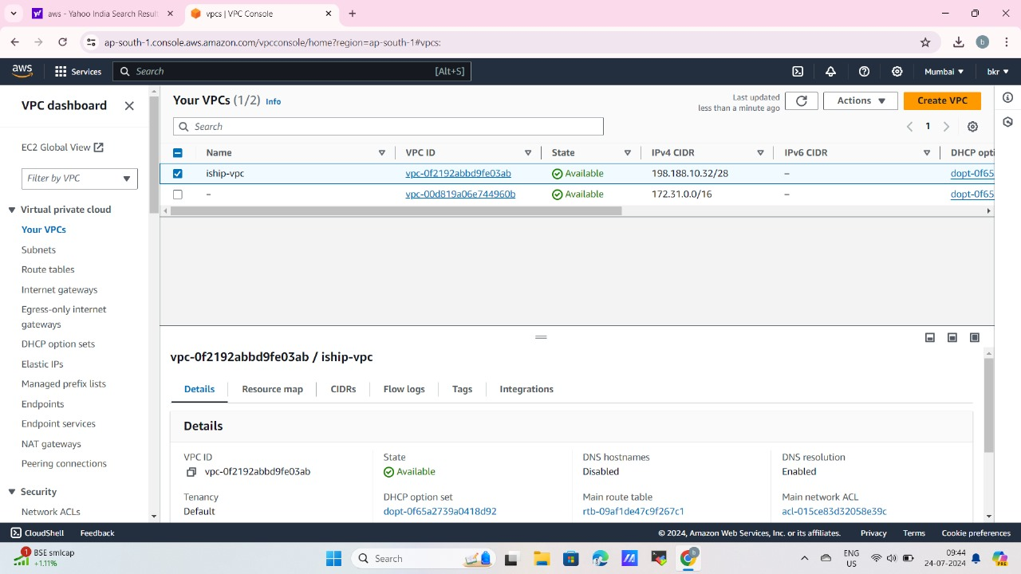

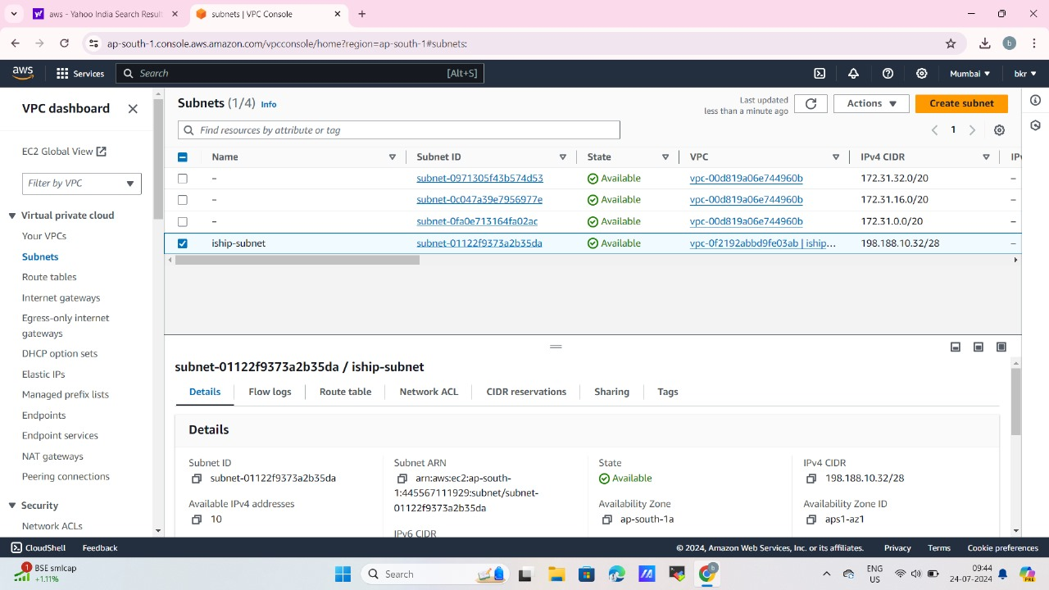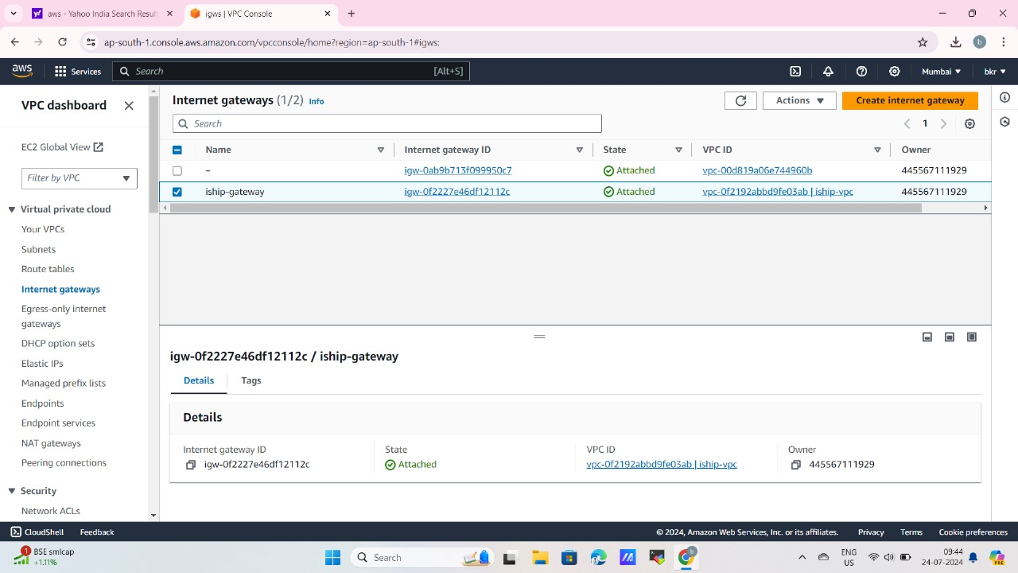

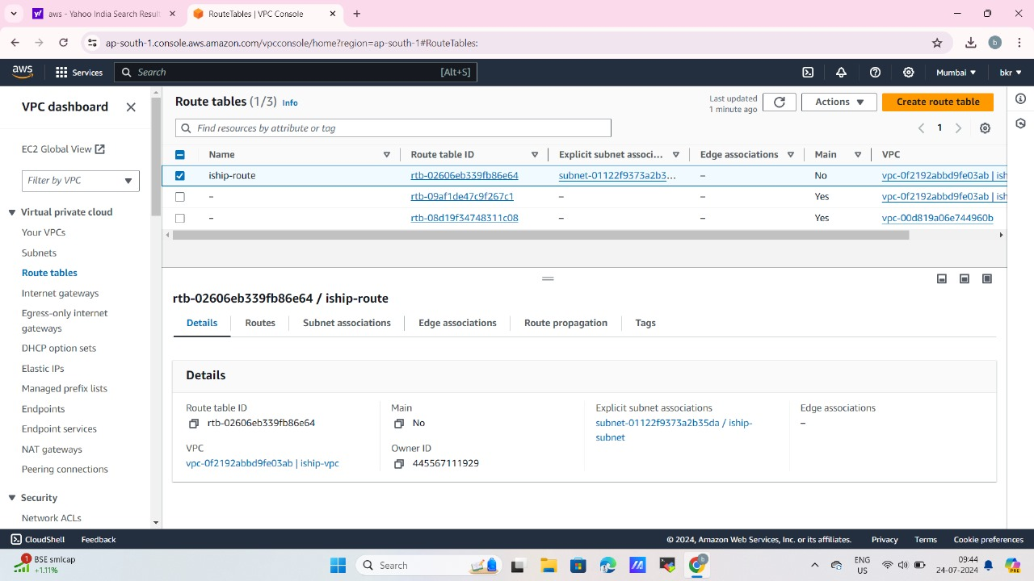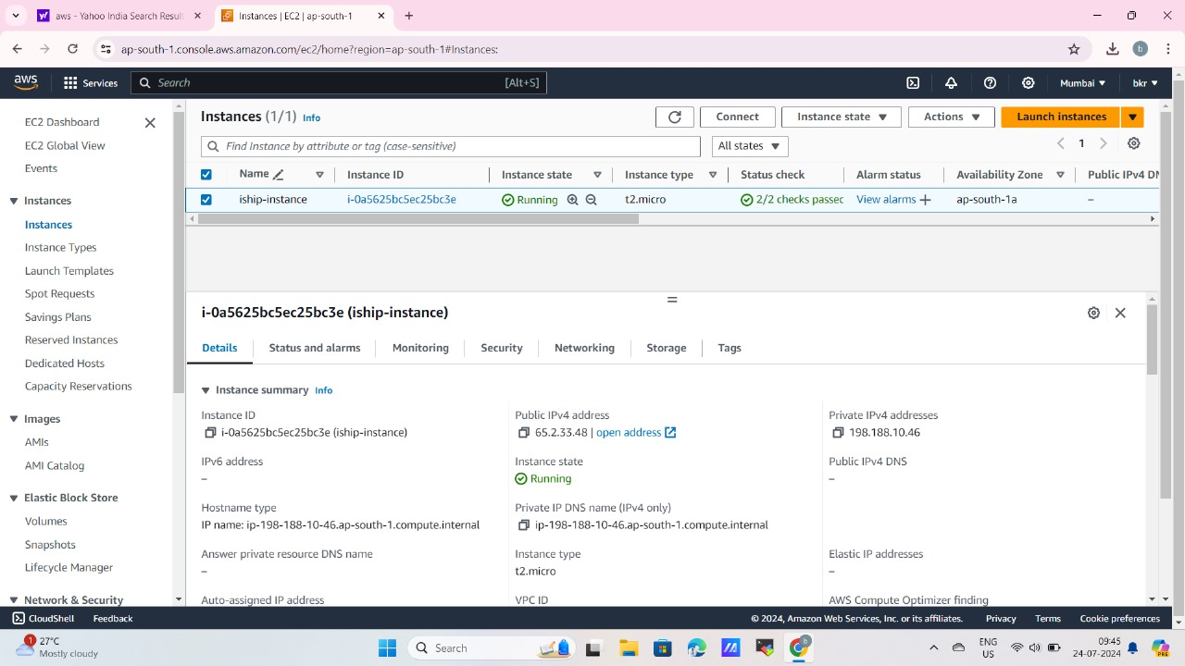

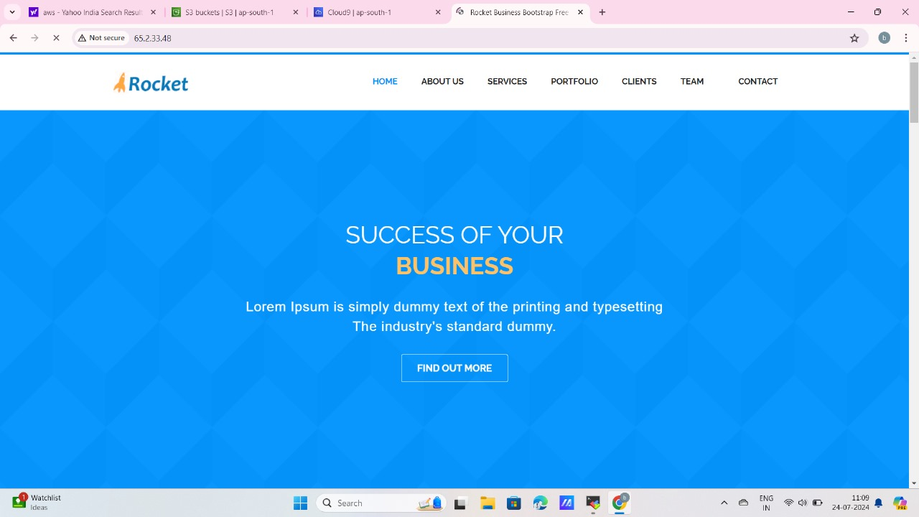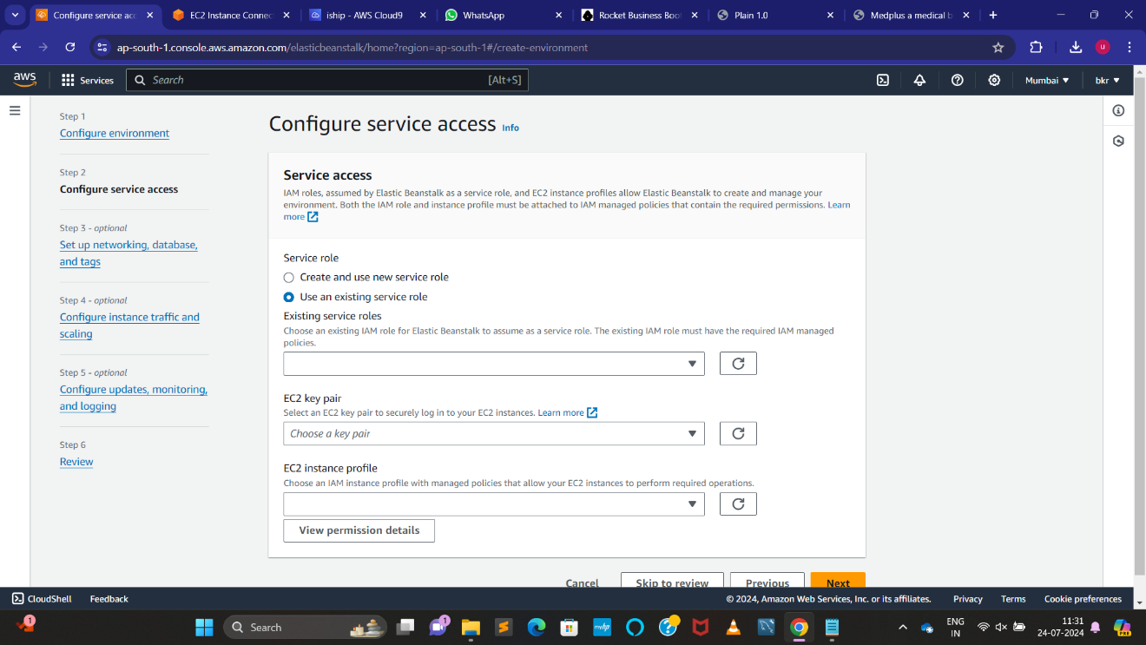

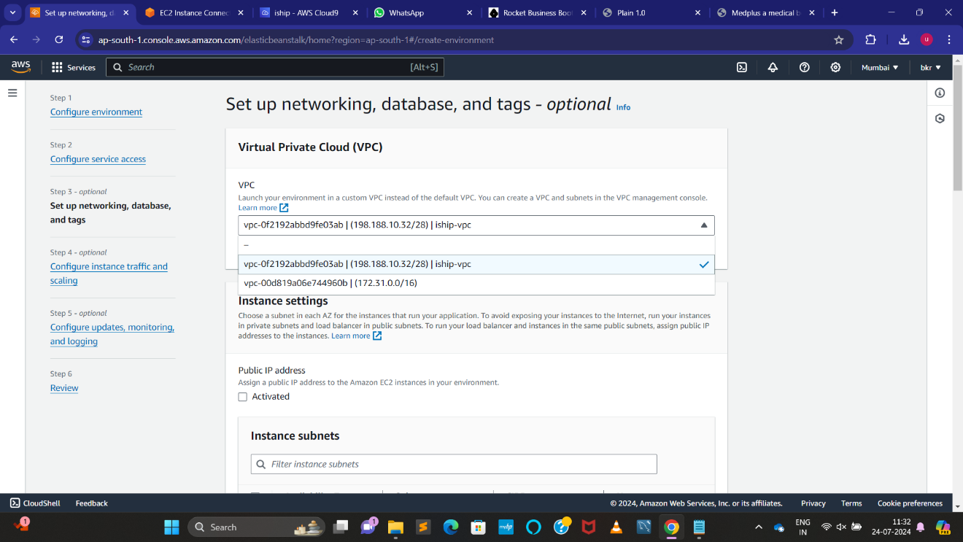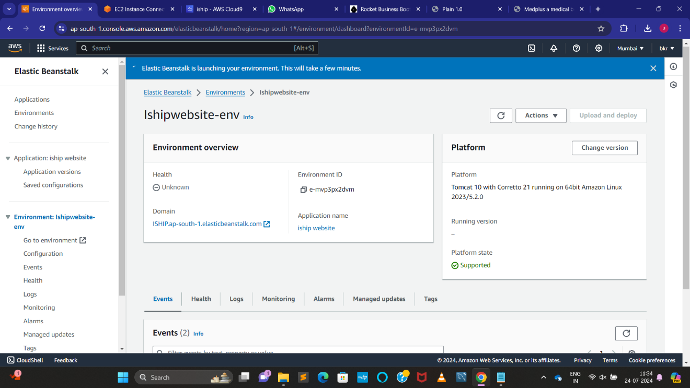

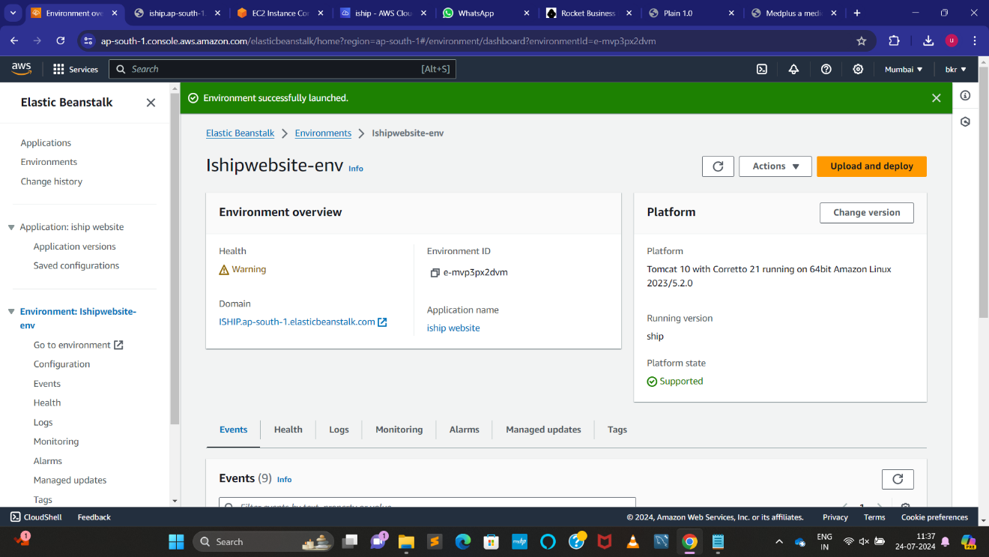

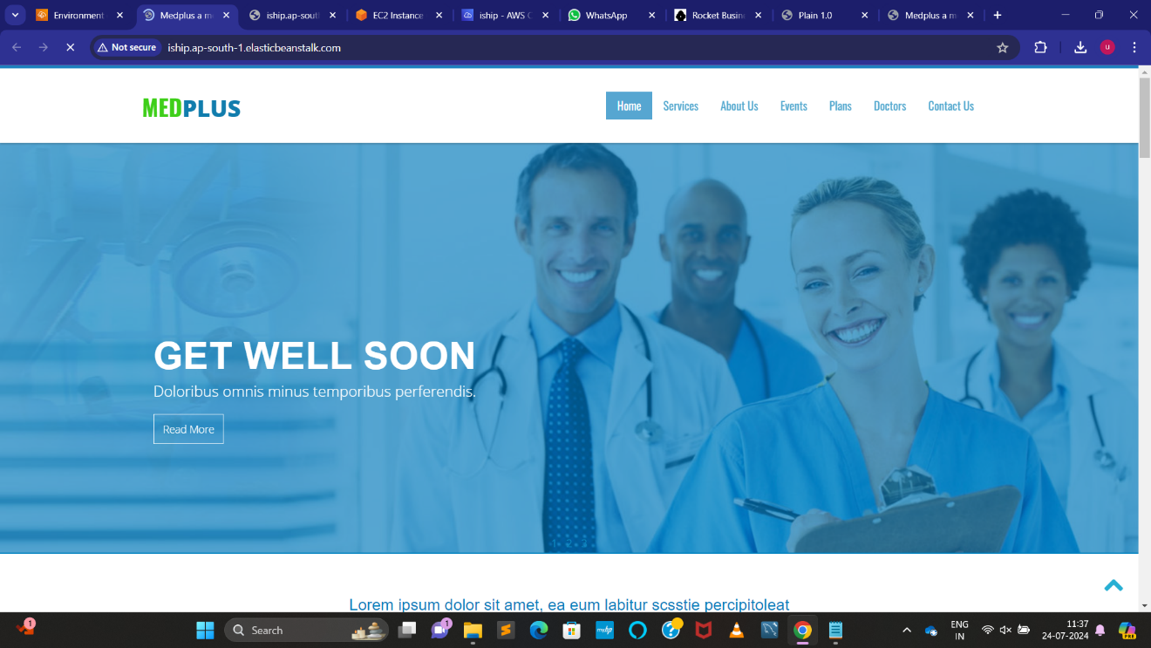

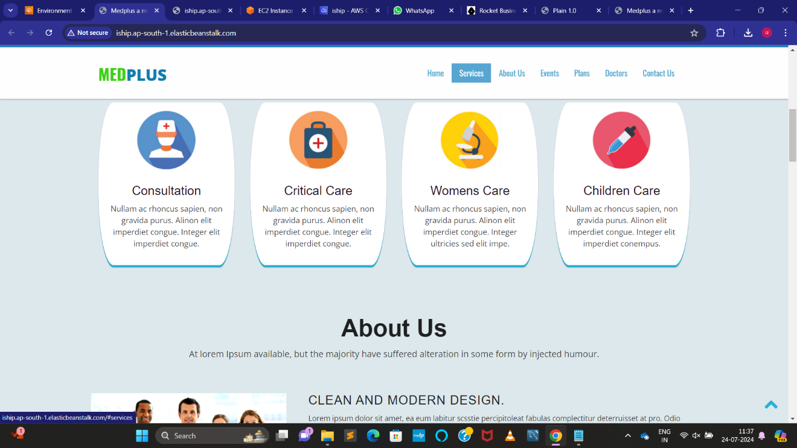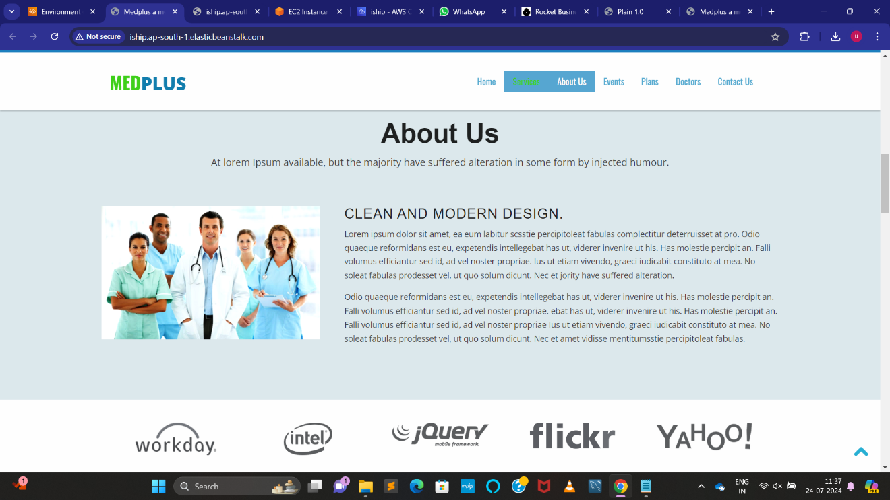

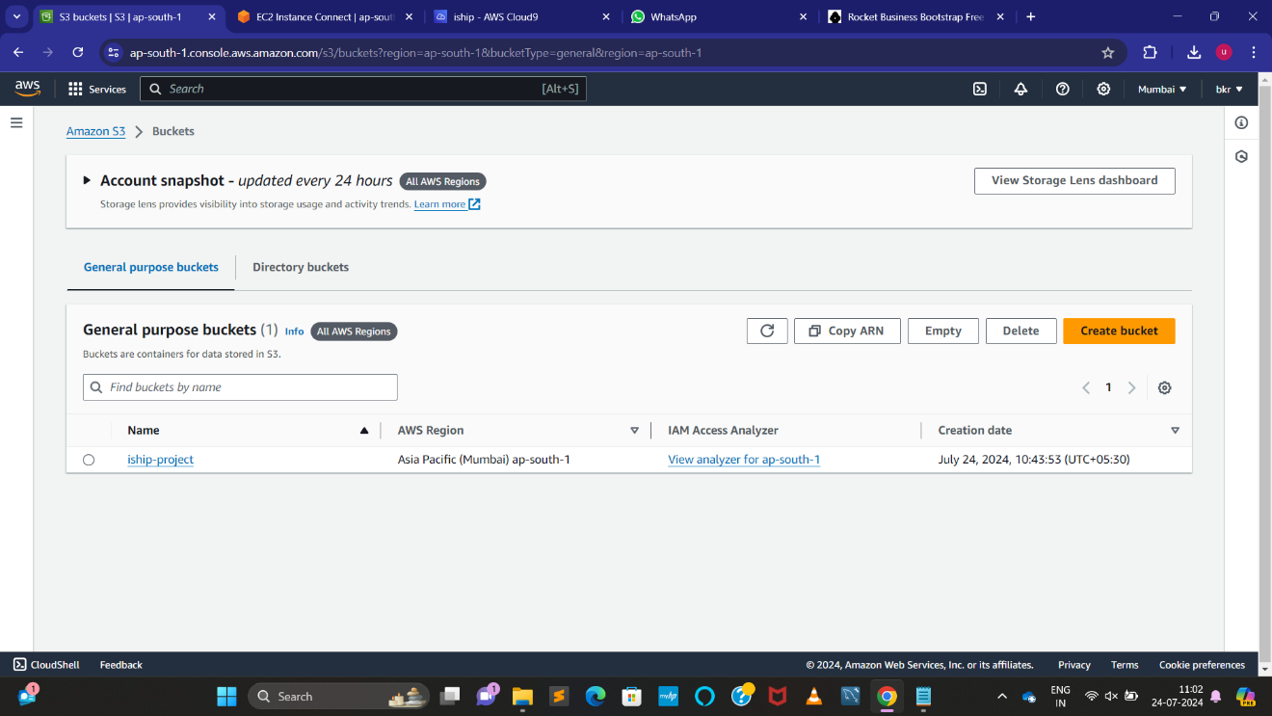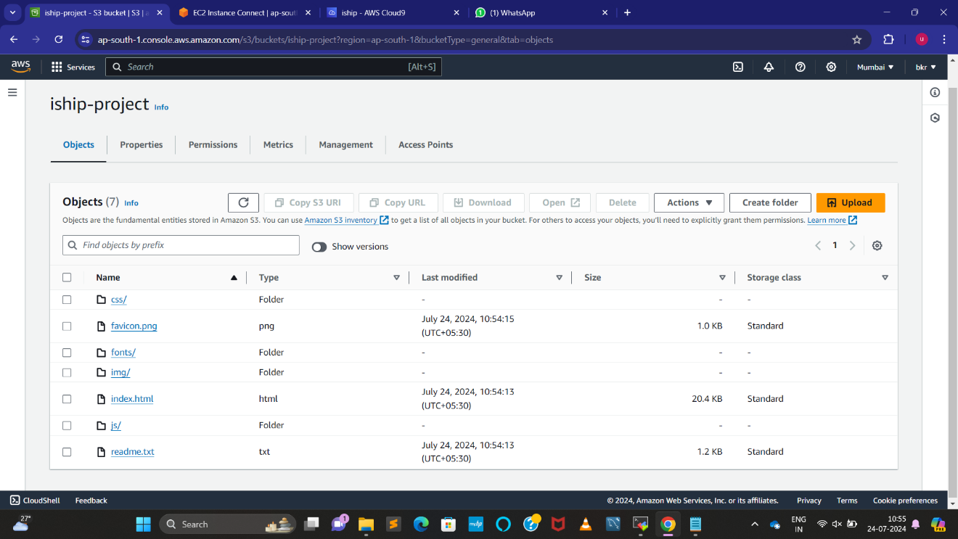

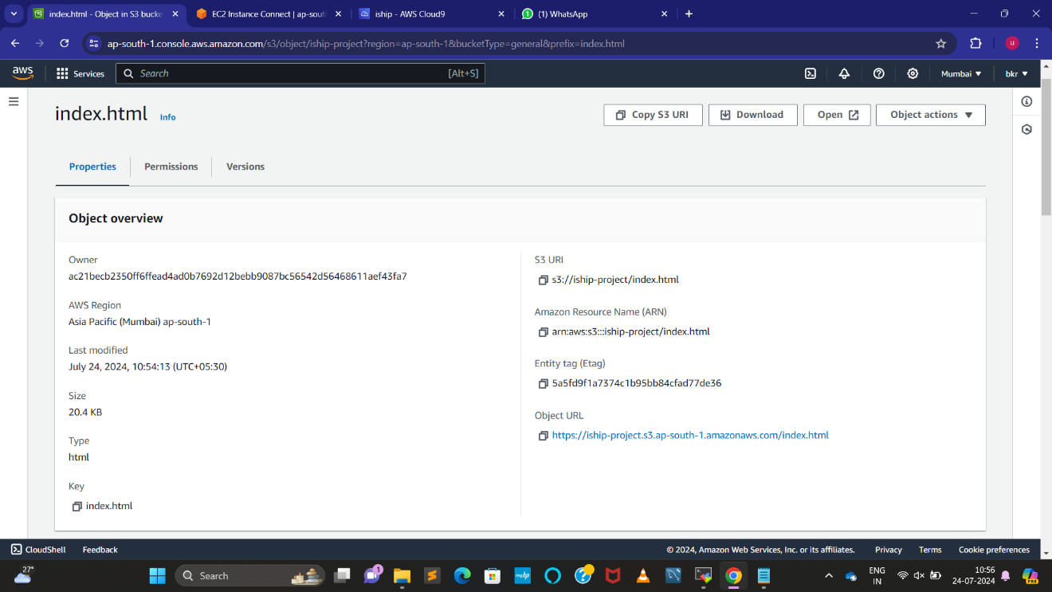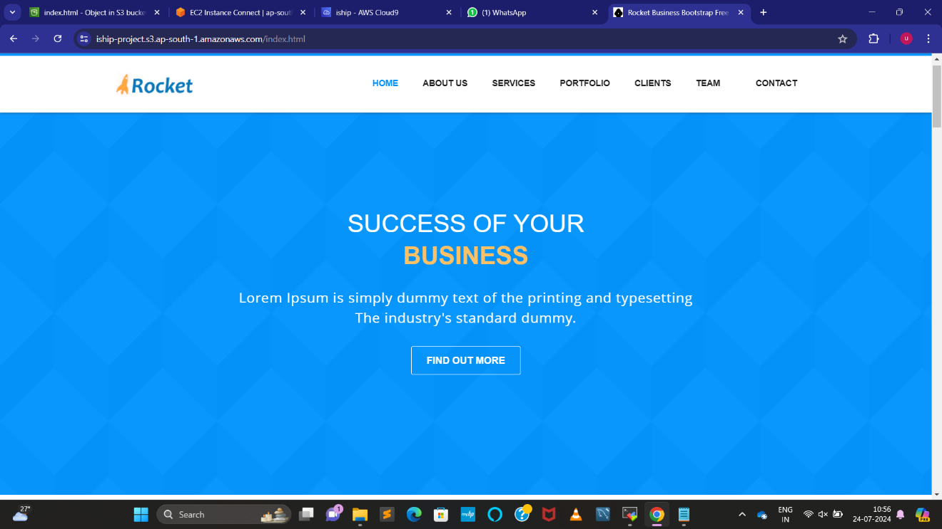

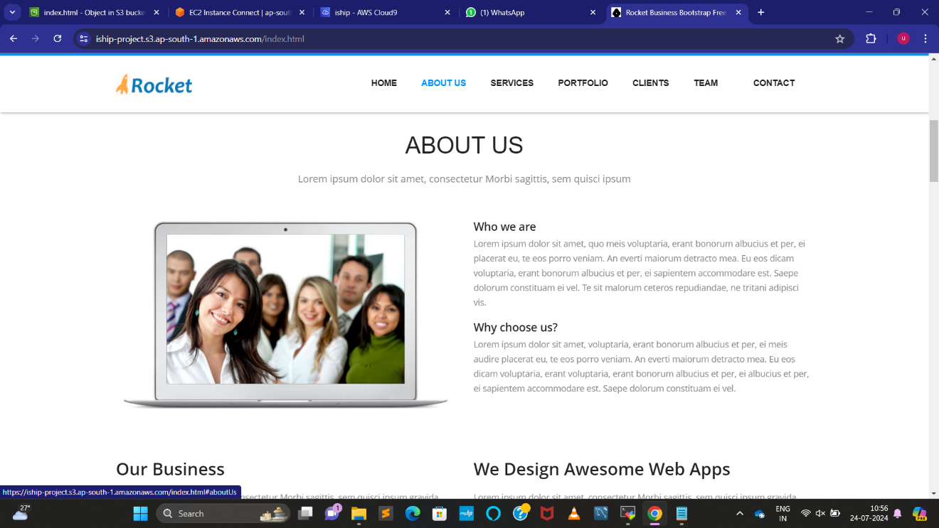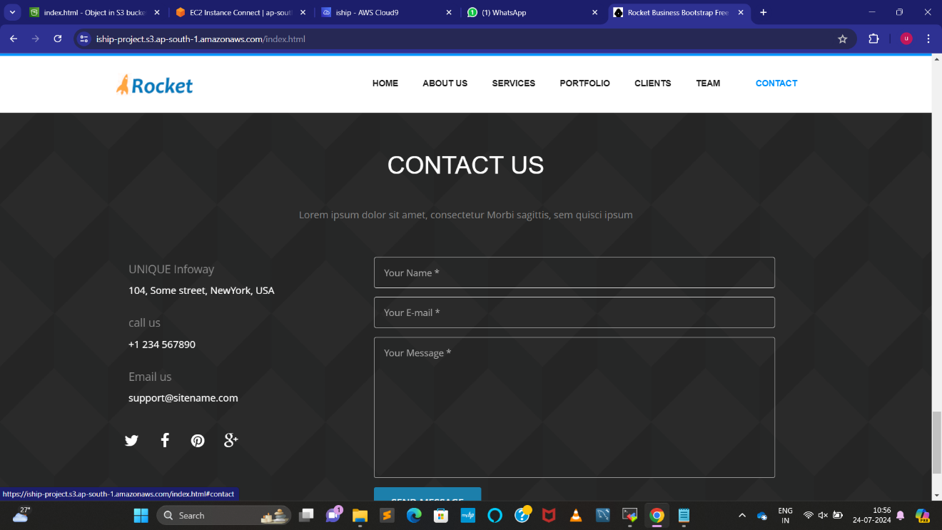

Github like : https://github.com/kotesh-battula/ISHIP-PROJECT